Linked Open Relations

Temporal relations draft

Last modification: 29-02-2012

# Introduction

This list of relations was based on previous work on time relations and reasoning, particularly on the OWL-Time ontology by Hobbs and Pan [1, 2]. Also, more recent work evaluating this ontology was considered [3].

This representation of time consider an absolute and linear time. These previously mentioned works are themselves based on previous work by Allen and Hayes [4], which recognizes the existence of time moments (indecomposable time intervals), points (time intervals with zero duration, reserved for beginnings and ends)[1] and intervals. There are 13 possible relations between them.

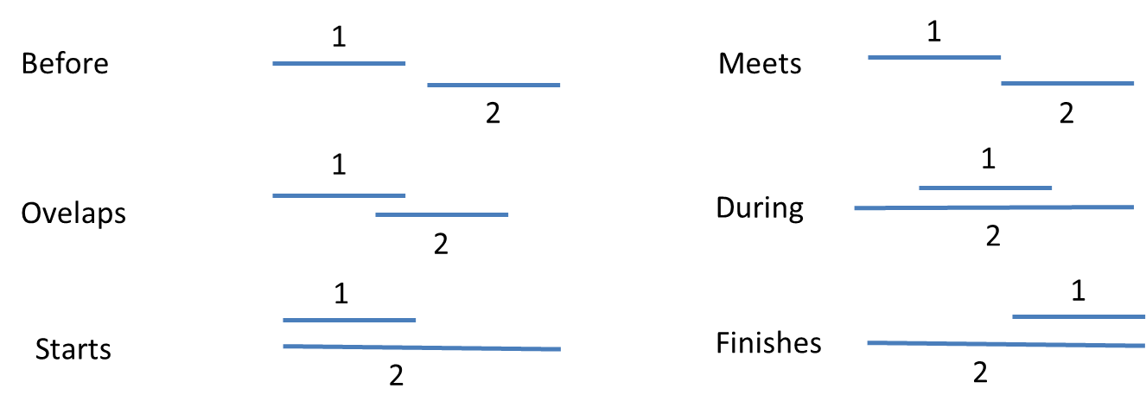[2]

The first 12 are: **before; overlaps; starts; meets; during; finishes**; and their inverses. The last relation is Equal.

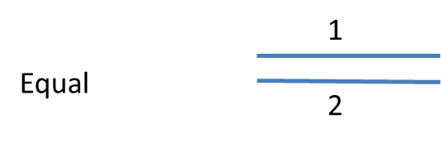

Another important use for time expressions in Semantic Web is the explicit assertion about time measures. **Duration** is a standard measure of time unfolding between the beginning and ending instant of an interval. Time instants can also be indexed according to international standards of time keeping (time zones, dates, and times).

All these relations can be formally defined and reasoned with by adding axioms. However, due to the volatile nature of the Semantic Web, these axioms must be flexible and extendable. For the time being, we will only use natural language definitions of those relations, referring to already existing axioms when required. Since our understanding of time is highly related to our understanding of space, it is useful to understand these relations as combinations of relations of order, parthood, boundary (only applies to contiguous intervals, not to scattered time spaces) and co-temporality. For instance, the **finishes** relation means that two time intervals share the finish boundary time instant.

# Summary of relations

Time relations

## First level canonical relations

Name: precedes

Definition: when projecting on a 1-dimensional ordered space, x precedes y iff all parts of x are on the left of any TimeInstant that isPartOf y.

Name: isTemporalPartOf

Definition: when projecting on a 1-dimensional ordered space, x isTemporalPartOf y iff all parts of x are parts of y. That is, every point belonging to x maps to a linear coordinate comprised by y.

Name: hasDurationDescription

Definition: when projecting on a 1-dimensional ordered space, x hasDurationDescription y iff the sum of every distinct TimeInstants that are part of x is equal to y in some standard measure. This relation relates TimeIntervals and InformationArtifacts.

Name: hasDateTimeDescription

Definition: when projecting on a 1-dimensional ordered space, x hasDateTimeDescription y iff the exact position of x is equal to y in some standard measure. This relation relates TimeInstant and InformationArtifacts.

## Second level relations

Name: overlapWith

Definition: when projecting on a 1-dimensional space, x overlapWith y iff there is at least 1 z that is part of both x and y, and z is a TimeInterval

Name: isTemporallyAdjacentTo

Definition: when projecting on a 1-dimensional space, x isTemporallyAdjacentTo y iff there is at least 1 z that is part of both x and y, and z is a TimeInstant

Name: hasBeginning

Definition: when projecting on a 1-dimensional space, x hasBeginning y iff ForAll x, y, z; TemporalInterval(x) AND TemporalInstant(y) AND TemporalInstant(z) AND isTemporalPartOf (y,x) AND isTemporalPartOf(z,x) AND y ≠ z AND precedes(y, z)

Name: #time-owl/IntervalDuring

Definition: when projecting on a 1-dimensional ordered space, x IntervalDuring y iff x isTemporalPartOf y AND there is some z part of y that precedes x and there is some w part of y that is preceded by x.

|  |  |  |  |
| --- | --- | --- | --- |
| before | intervalEquals | intervalDuring | intervalStartedBy |
| after | intervalBefore | intervalFinishes | intervalContains |
| hasBeginning | intervalMeets | intervalAfter | intervalFinishedBy |
| hasEnd | intervalOverlaps | intervalMetBy | hasDurationDescription |
| inside | intervalStarts | intervalOverlappedBy | hasDateTimeDescription |

NOTES:

1. Intervals can be generalized by boundary and co-temporality, e.g. x intervalFinishes y = hasBeginning(x, t2) AND hasBeginning(y, t1) AND hasEnd(x, t3) AND hasEnd(y, t3) AND after(t2, t1) AND intervalDuring(x, y).
2. Meets and MetBy could be generalized to sharing a boundary and adding the after or before relation; could there be implications for reasoning and would they matter?
3. Overlaps can be represented as having the end boundary inside some interval and the begin before the beginning of that interval and some interval part during it. – also could have implications for reasoning
4. In order to define the relations according to numerical values ("x intervalAfter y iff hasDateTimeDescription (hasBeginning(x)) > hasDateTimeDescription (hasEnd(y)) "), the **hasDateTimeDescription** must contain reference to a universally valid time description, including time zones. This will be essential only in dynamic applications such as scheduling.

# Detailed relations

TODO

- a relation type name (containing a verb in the third person singular)  
- a natural language definition (mentioning the 'metalevel', a scope, problems and an example)  
- algebraic properties  
- synonyms

# Usage and mapping examples

OBO mapping

For clarity purposes I am omitting the projection relations between occurrents and temporal intervals, and considering occurrents AS temporal intervals – this should be reviewed!

|  |  |  |
| --- | --- | --- |
| OBO relations |  | Mapping |
| after |  | after |
| begins at end of' |  | X intervalMetBY y |
| coincides with' |  | intervalEquals |
| during |  | intervalDuring |
| end |  | hasEnd |
| end_of |  | intervalFinishes |
| ends existing during' |  | Continuant AND participantOf some (ContinuantLife AND hasPart some (ContinuantLifeEnd intervalDuring y)) |
| starts and ends existing during' |  | Continuant AND participantOf some (ContinuantLife AND hasPart some (ContinuantLifeBegin intervalDuring y) AND hasPart some ((ContinuantLifeEnd intervalDuring y) |
| ends_at |  | X intervalFinishedBy y |
| ends_at_beginning_of |  | X intervalMeets y |
| ends_during |  | X intervalOverlaps y |
| has_duration |  | hasDurationDescription |
| is directly preceded by' |  | X intervalMeets y |
| is preceded by' |  | X before y |
| is_extinct |  | Continuant AND participantOf only (ContinuantLife before now) |
| simultaneous_with |  | intervalEquals |

DBPedia time relations

|  |  |  |
| --- | --- | --- |
| birthDate |  | Person AND participantOf some (PersonLife AND hasBeginning some (TimeInstant AND inside some (TimeInterval AND hasDateTimeDescription some XSDDateTime)) |
| firstPublicationYear |  | Publication AND outputOf some (PublicationProcessX AND intervalOverlaps some (YearInterval AND hasDateTimeDescription some XSDDateTime) NOT intervalAfter some PublicationProcessX) |
| firstFlight |  | SpaceShuttle AND participantOf some (SpaceFlight NOT intervalAfter some SpaceFlight) |
|  |  |  |

1. Hobbs, J.R. and F. Pan, *Time Ontology in OWL*, Ontology Engineering Patterns Task Force of the Semantic Web Best Practices and Deployment Working Group, Editor. 2006, World Wide Web Consortium (W3C).

2. Pan, F., *Representing Complex Temporal Phenomena for the Semantic Web and Natural Language*, in *Computer Science Department,*. 2007, University of Sothern California.

3. Gruninger, M., *Verification of the OWL-time ontology*, in *Proceedings of the 10th international conference on The semantic web - Volume Part I*. 2011, Springer-Verlag: Bonn, Germany. p. 225-240.

4. Allen, J.F. and P.J. Hayes, *Moments and points in an interval-based temporal logic.* Comput. Intell., 1990. **5**(4): p. 225-238.

1. Hobbs and Pan unify the moments and points as instants.
2. Picture based on presentation of the Formal Ontology for Knowledge Representation and Natural Language Processing - May 3rd, 2005, of the Laboratory for Applied Ontology of the Institute of Cognitive Science and Technology, available at <http://www.loa.istc.cnr.it/Tutorials/TimeOnto.pdf>